**Objective Questions:**

1. What is the distribution of account balances across different regions?

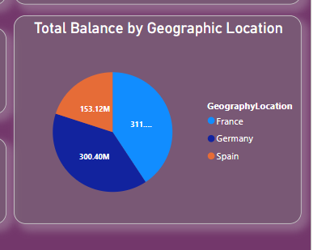

The numbers of customers account in France, Germany and Spain are so high, So, their account balances are also high.

1. Identify the top 5 customers with the highest Estimated Salary in the last quarter of the year. (SQL)

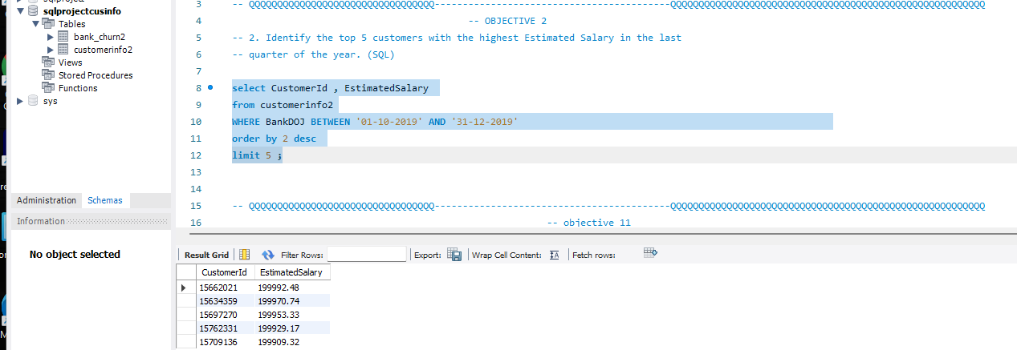

1. Calculate the average number of products used by customers who have a credit card. (SQL)

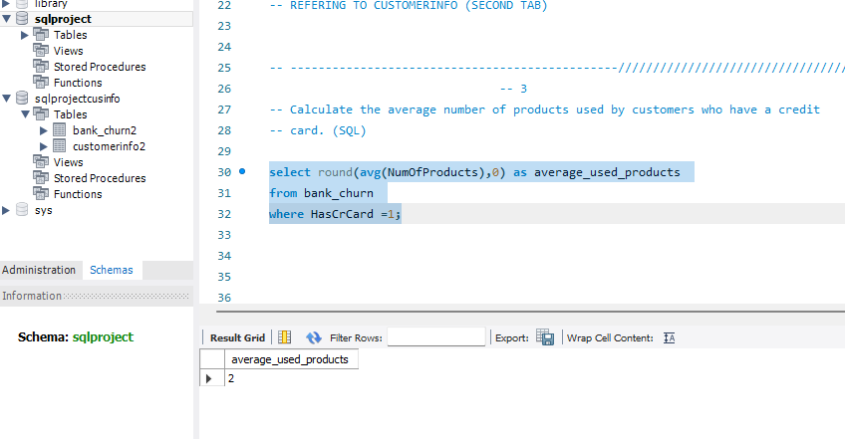

From the Query, the customers who have credit card mostly as their number of products. = average_used_products = 2

1. Determine the churn rate by gender for the most recent year in the dataset.

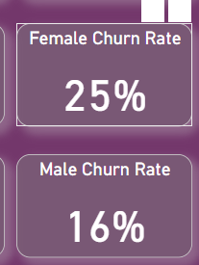

The churn rate for female is 25% while for males it stands at 16%

1. Compare the average credit score of customers who have exited and those who remain. (SQL)

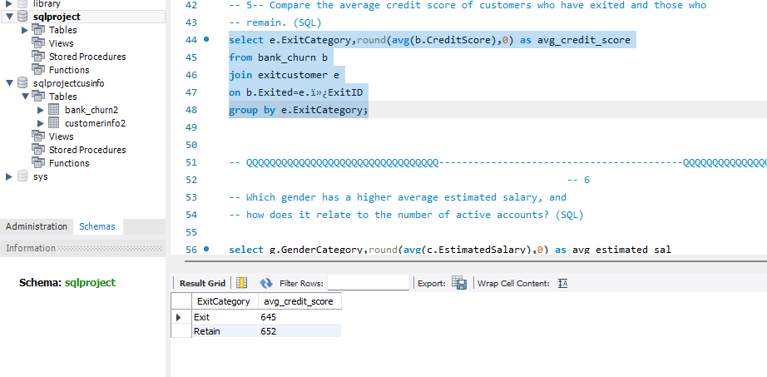

The Customers who have left the bank possess an average credit score of 645, whereas those who have remained have an average credit score of 652.

1. Which gender has a higher average estimated salary, and how does it relate to the number of active accounts? (SQL)

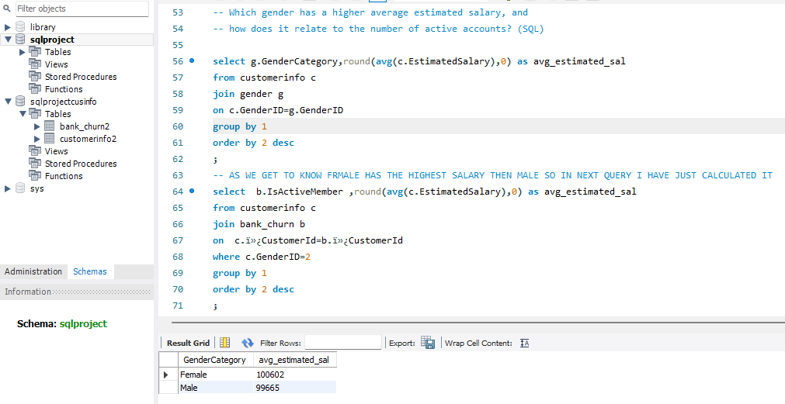

Female has highest average estimated salary of around 100602 even though they are having a smaller number of active accounts than the Male= 99665

1. Segment the customers based on their credit score and identify the segment with the highest exit rate. (SQL)

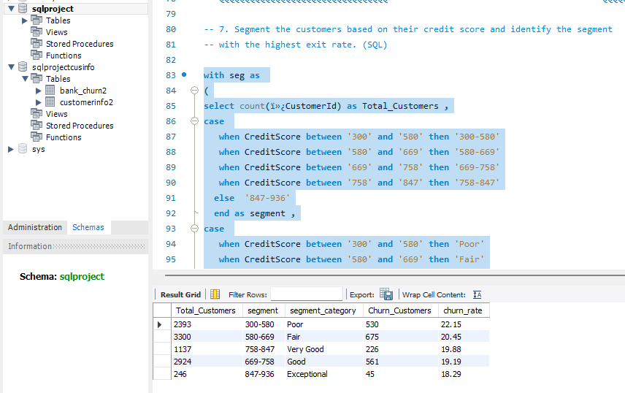

The customer’s credit score has been segmented as :

Exceptional: 847–936,

Very Good: 758–847,

Good: 669–758,

Fair: 580–669,

Poor: 300–580.

The customer’s having Fair as their credit score worthiness has the highest exit rate is Poor (22.15%).

1. Find out which geographic region has the highest number of active customers with a tenure greater than 5 years. (SQL)

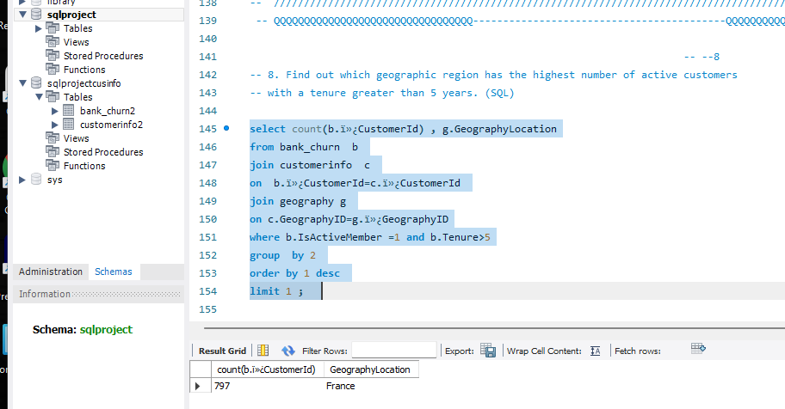

Among geographic locations, France stands out with the highest count of active customers, totalling 1477, who have a tenure exceeding 5 years.

1. What is the impact of having a credit card on customer churn, based on the available data?

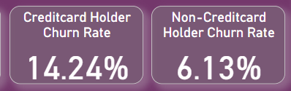

The customers with credit card who remained in the bank is higher than the exited people. So, there is no impact of having a credit card on customer churn.

1. For customers who have exited, what is the most common number of products they have used?

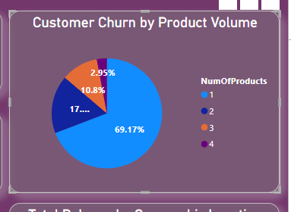

The most common number of products used by exited customers is 1.

1. Examine the trend of customers joining over time and identify any seasonal patterns (yearly or monthly). Prepare the data through SQL and then visualize it.

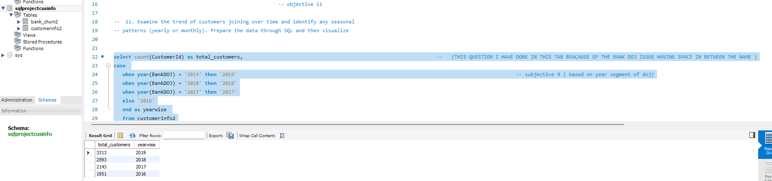

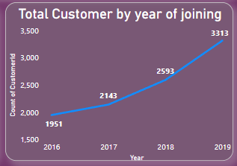

1. Analyze the relationship between the number of products and the account balance for customers who have exited.

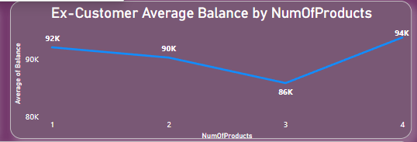

* The average balance tends to decrease as the number of products increases. This suggests that exited customers with a higher number of products generally have lower average balances compared to those with fewer products.  
    
  Possible Reasons   
    
  1.Customers who buy more products might spend their balance down to zero or close to it.  
  2.Customers who are dissatisfied with a product purchase might be more likely to exit and may have a lower remaining balance due to returns or not completing payments.  
  3.Customers with lower balances might be more likely to purchase a wider variety of products (exploring options) before exiting.

1. Identify any potential outliers in terms of balance among customers who have remained with the bank.

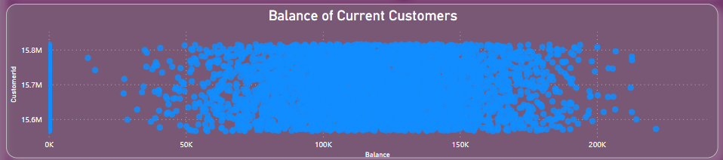

The Most customers who do not have four products are typically retained by the bank.

1. How many different tables are given in the dataset, out of these tables which table only consists of categorical variables?

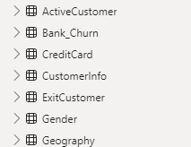

Total 7 tables are there in the dataset out of which 5 has categorical data in it.

1. Using SQL, write a query to find out the gender-wise average income of males and females in each geography id. Also, rank the gender according to the average value. (SQL)

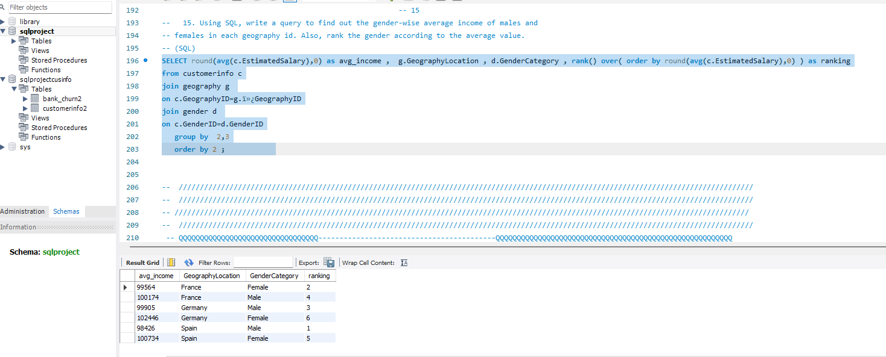

By using Rank Function, I have ranked the gender-wise average income of males and females in each geography id

1. Using SQL, write a query to find out the average tenure of the people who have exited in each age bracket (18-30, 30-50, 50+).

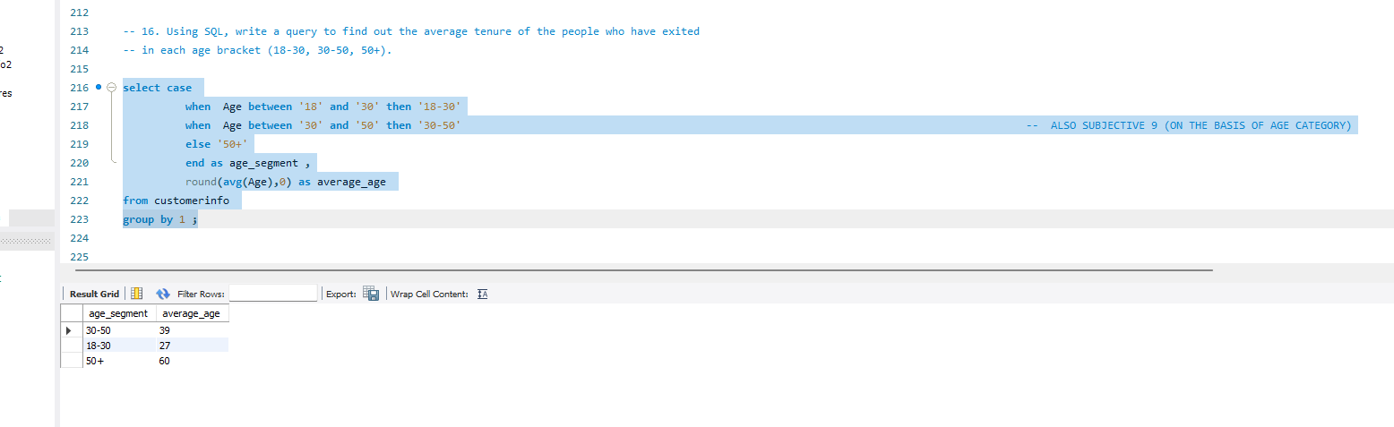

1. Is there any direct correlation between salary and the balance of the customers? And is it different for people who have exited or not?

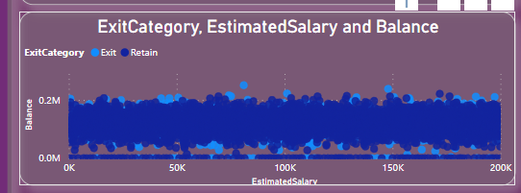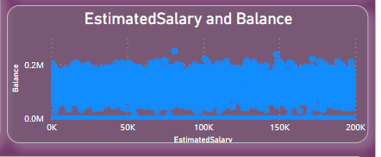

According to current graph condition there is no such correlation between the estimated salary and balance and this is also same for the churn customers

1. Is there any correlation between the salary and the Credit score of customers?

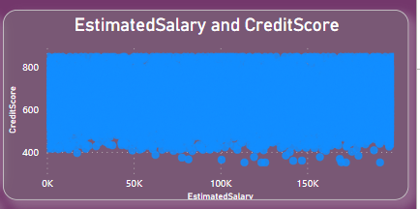

We can clearly see from the graph that there is no correlation between the estimated salary and credit score

1. Rank each bucket of credit score as per the number of customers who have churned the bank.

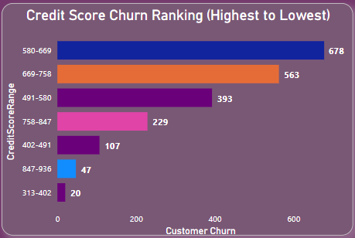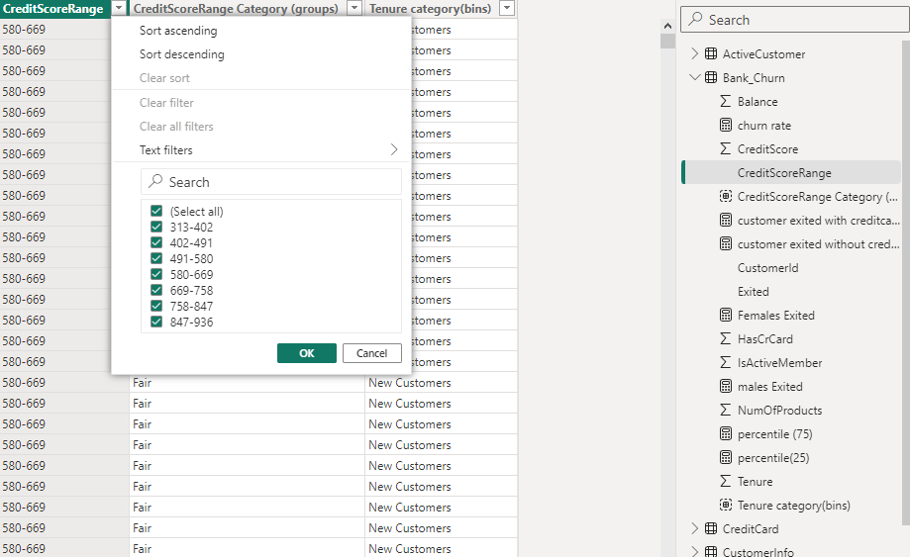

To make each bucket for credit score I have grouped the credit score range and then I have just calculated it in power bi using stack bar chart

1. According to the age buckets find the number of customers who have a credit card. Also retrieve those buckets that have lesser than average number of credit cards per bucket.

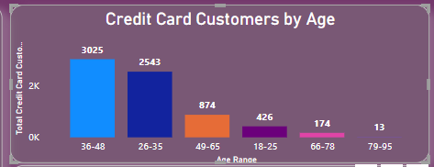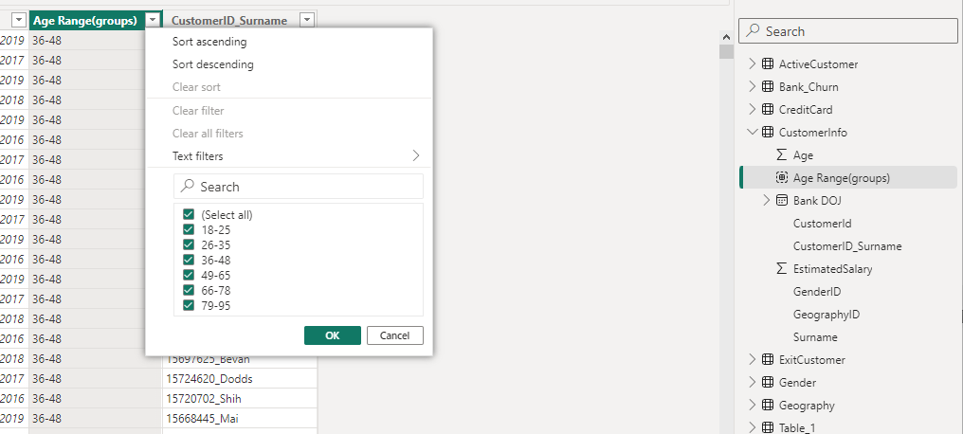

To make age bucket I have just grouped the data from customer info age column And then just calculated it through Stacked column chart

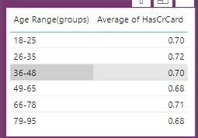

We can clearly see from the above picture that age range between 49 to 65 and 79 to 95 have less number of average cards among all

1. Rank the Locations as per the number of people who have churned the bank and average balance of the customers.

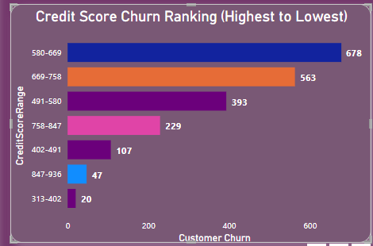

1. As we can see that the “CustomerInfo” table has the CustomerID and Surname, now if we have to join it with a table where the primary key is also a combination of CustomerID and Surname, come up with a column where the format is “CustomerID_Surname”.

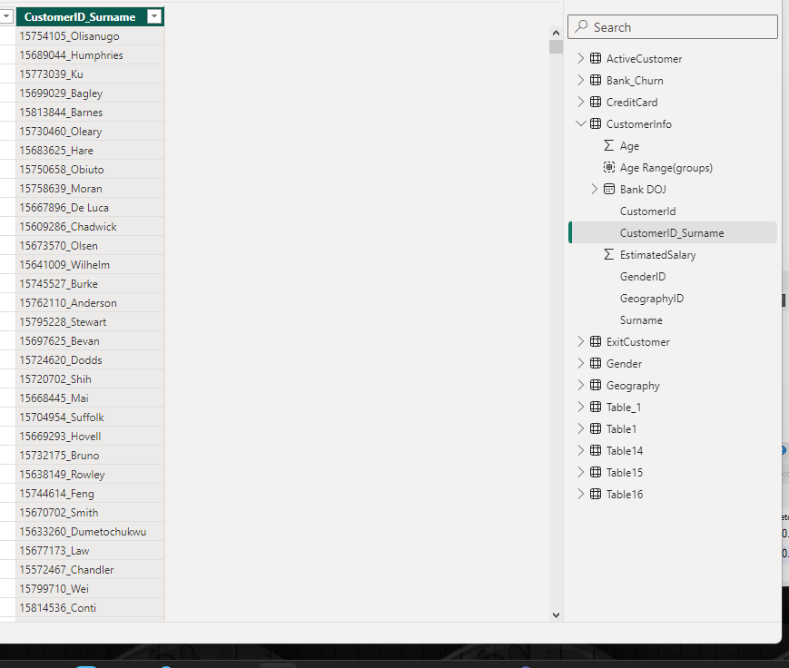

1. Without using “Join”, can we get the “ExitCategory” from ExitCustomers table to Bank_Churn table? If yes do this using SQL.

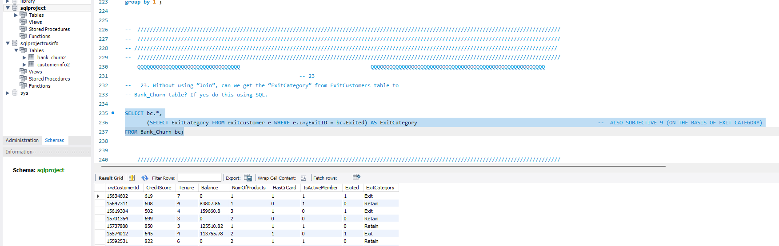

1. Were there any missing values in the data, using which tool did you replace them and what are the ways to handle them?

In Power BI, I utilized the Power Query Editor tool to address missing data points within the dataset. Employing this tool, I identified and rectified instances where data was absent or contained empty cells. By leveraging the functionalities of the editor, I systematically replaced these missing values. This involved either assigning a specific predetermined value to the empty cells or dynamically filling them with the value from the preceding non-blank cell. This process ensured that our subsequent analysis was conducted on a dataset devoid of any gaps, thereby enhancing the reliability and accuracy of our insights.

1. Write the query to get the customer IDs, their last name, and whether they are active or not for the customers whose surname ends with “on”.

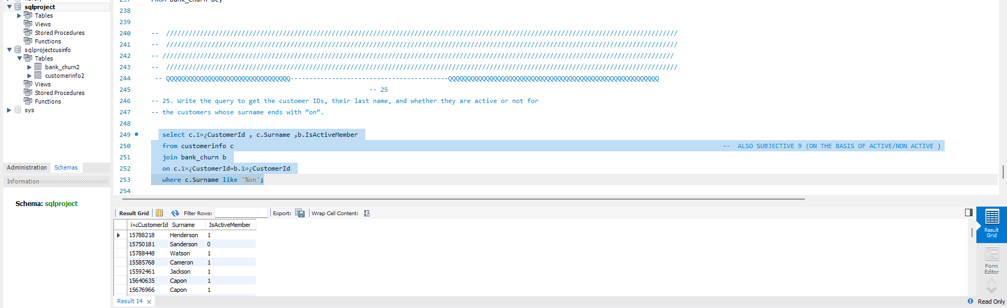

**Subjective Question:**

* 1. Customer Behavior Analysis: What patterns can be observed in the spending habits of long-term customers compared to new customers, and what might these patterns suggest about customer loyalty?

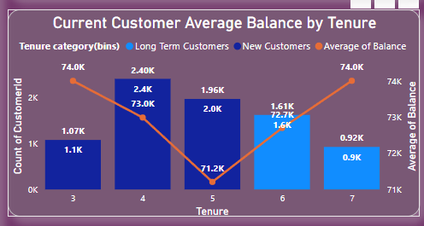

Potentially Higher Spending by Long-Term Customers: The graph suggests that long-term customers (6-7 years) tend to have a higher average balance than new customers (3-5 years). This could indicate an increase in spending habits over time with the bank.

Trust and Familiarity: Over time, customers develop trust and familiarity with the bank's offerings. This can lead them to feel comfortable keeping a higher average balance in their accounts. They might be more confident using the bank's services for various financial needs, like saving for a house or managing investments.  
Habit Formation: Regular use of the bank's services can become ingrained for long-term customers. This consistent engagement translates to higher average balances as these customers rely more heavily on the bank's ecosystem for their financial activities.

* 1. Product Affinity Study: Which bank products or services are most commonly used together, and how might this influence cross-selling strategies?

Although we don’t have sufficient data in the data set about services and products used by the each customer ( we only have count of customers used by customer on which the below analysis is given ).

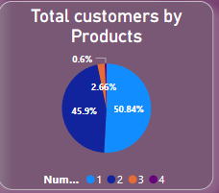

Nearly 50.84% of total customers uses only one product .

High Usage of Multiple Products: The two largest slices (45.9% and 50.84%) represent customers using two or more products. This suggests a significant portion of the customer base utilizes multiple banking services, indicating potential product affinity.  
Cross-Selling Strategies:  
  
Knowing that a large portion of the customer base already uses multiple products strengthens the case for cross-selling strategies:  
  
Segment by Usage: Banks can segment customers based on the number of products they use (1, 2, 3, or 4). This allows for targeted marketing campaigns promoting relevant products to each segment.  
Highlight Bundles: For customers using only two products (45.9% slice), promoting bundled packages that combine frequently used products at a discount can be effective.  
Upselling Opportunities: For customers using one product (50.84% slice), banks can identify upselling opportunities by recommending additional products or services that complement their existing product usage.

* 1. Geographic Market Trends: How do economic indicators in different geographic regions correlate with the number of active accounts and customer churn rates?

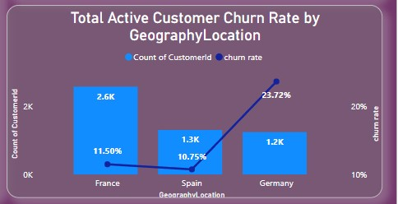

France: Despite having the highest number of active accounts (2.6k), France also has the highest customer churn rate (23.72%). This suggests other factors besides economic conditions might be driving churn in France.  
Spain: Spain has a lower churn rate (11.50%) compared to France, but also a lower number of active accounts (1.3k). This could indicate a more stable customer base in Spain, but also potentially slower growth.  
Germany: Germany has the lowest churn rate (10.75%) and the lowest number of active accounts (1.2k). This suggests they might have a very loyal customer base, but also face challenges in customer acquisition.

* 1. Risk Management Assessment: Based on customer profiles, which demographic segments appear to pose the highest financial risk to the bank, and why?

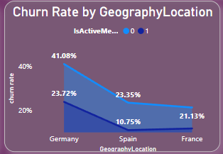

Germany pose to be highest financial risk for the bank as it has Highest churn rate of active and inactive customers as it has the highest churn rates .  
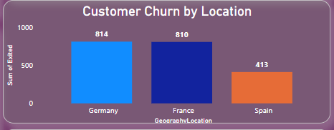

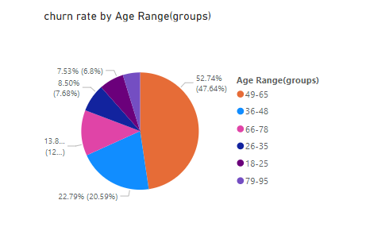

The reason why choose demographic segment is because age factor is common for both male and female which has high impact on bank’s financial risk. From the above visualizations, middle age bracket people have the highest rate of churn. At the age bracket between 30 and 50, all the people will try to put the investments, but at the time customers are exiting from the bank. It could cause high financial risk to the bank.

Spain = 20.02%

France = 40.7%

Spain = 39.28%

* 1. Customer Tenure Value Forecast: How would you use the available data to model and predict the lifetime (tenure) value in the bank of different customer segments?

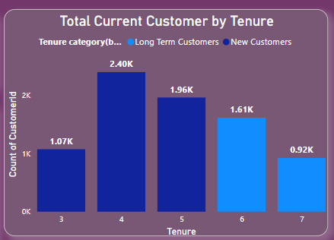

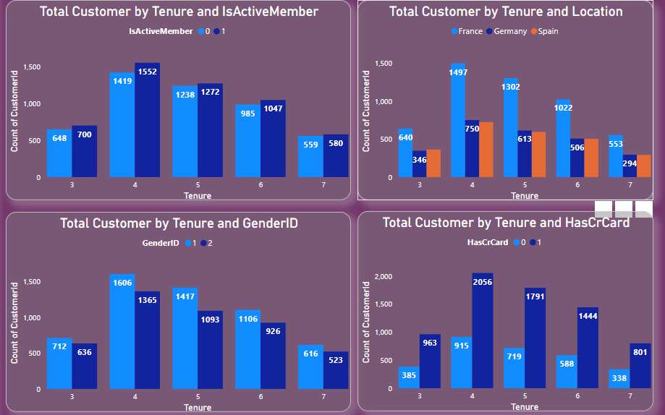

* 1. Marketing Campaign Effectiveness: How could you assess the impact of marketing campaigns on customer retention and acquisition within the dataset? What extra information would you need to solve this?

Marketing campaigns will definitely help the bank to bring in more customers and increase customer retention .  
But to properly analyse the impact of marketing campaigns we need extra information like retention rate , acquisition rate and many more .

* 1. Customer Exit Reasons Exploration: Can you identify common characteristics or trends among customers who have exited that could explain their reasons for leaving?

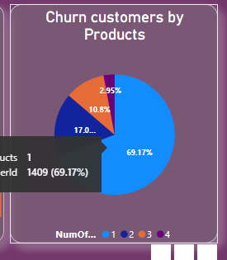

The most common characteristic among customers who have exited the bank is that they 69.71% uses only one product .

* 1. Are 'Tenure', 'NumOfProducts', 'IsActiveMember', and 'EstimatedSalary' important for predicting if a customer will leave the bank?

Yes, all four features (tenure, number of products, active member status, estimated salary) are likely important for predicting customer churn. They signal factors like loyalty, engagement, investment in the bank's ecosystem, and potentially financial stability - all influencing a customer's decision to stay or leave. These along with other data points can be used in churn prediction models to identify at-risk customers and develop targeted retention strategies.

* 1. Utilize SQL queries to segment customers based on demographics and account details.

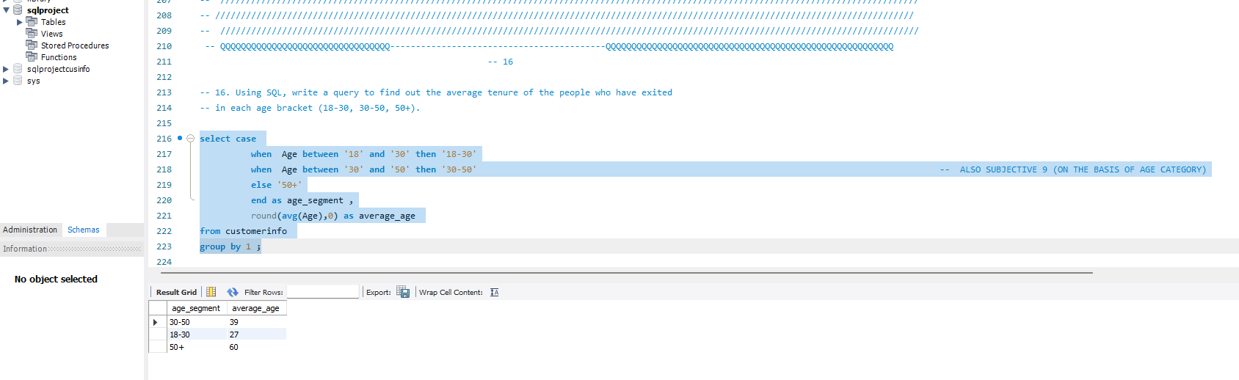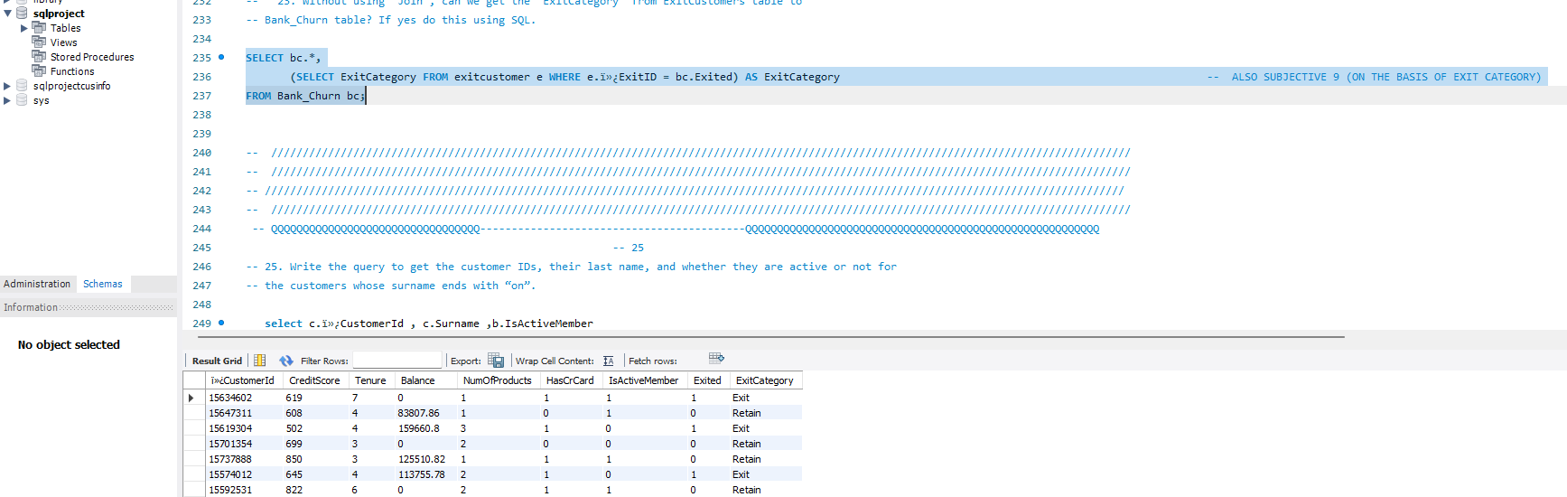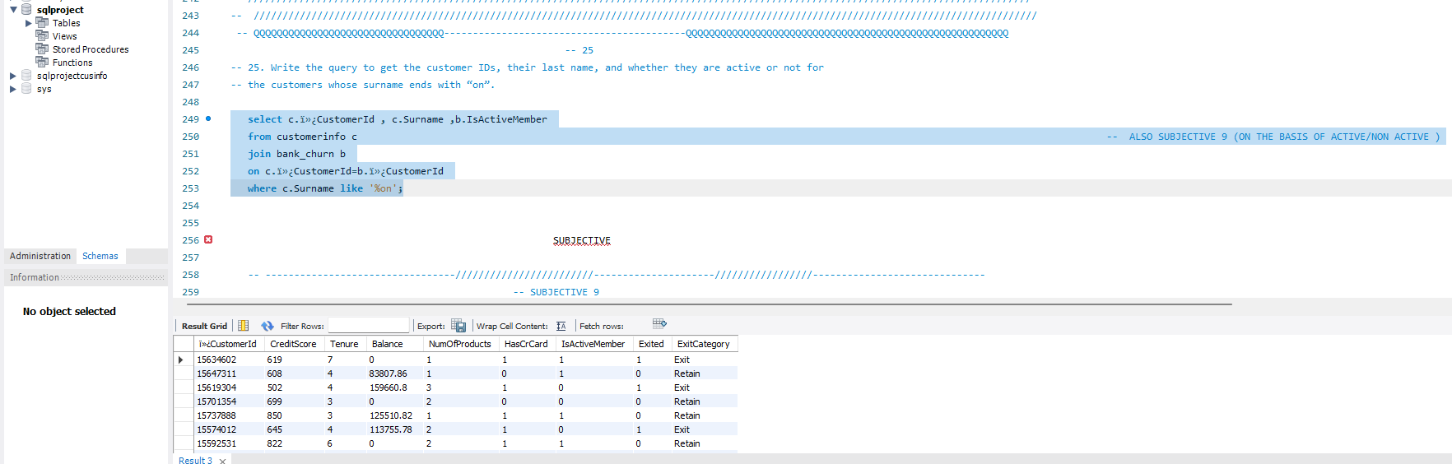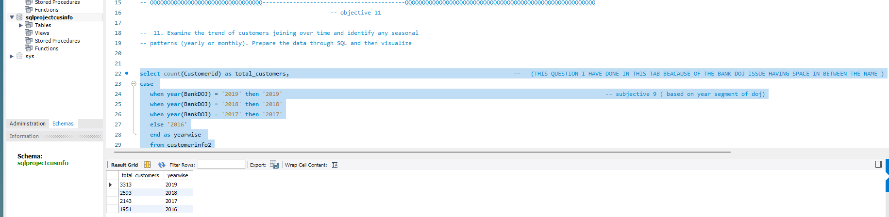

* 1. How can we create a conditional formatting setup to visually highlight customers at risk of churn and to evaluate the impact of credit card rewards on customer retention?

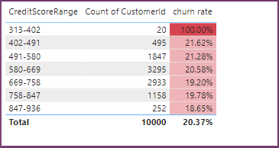

The churn rate is generally lower for customers with higher credit scores. For example, the churn rate for customers with a credit score in the 758-847 range is 18.65%, whereas the churn rate for customers with a score in the 313-402 range is 100%.

Without data on customer reward program engagement, it's difficult to say definitively whether these rewards programs are having a causal impact on retention. However, the correlation between credit score and churn rate suggests that it could be a factor.

* 1. What is the current churn rate per year and overall as well in the bank? Can you suggest some insights to the bank about which kind of customers are more likely to churn and what different strategies can be used to decrease the churn rate?

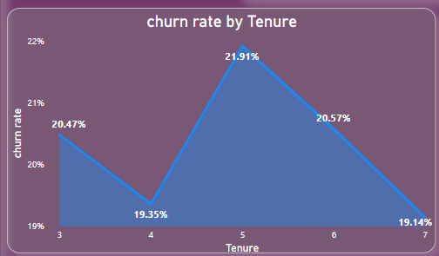

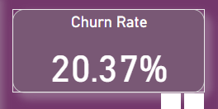

Customers Who uses only one product or more likely to turn than the customers who uses 2 and more number of products.

Offer Incentives: Consider loyalty programs, rewards points, or targeted discounts to encourage customers to keep using your bank's services.  
Personalize the Experience: Get to know your customers' needs and preferences. Recommend relevant products or services, and tailor marketing messages to resonate with them.  
Provide Excellent Customer Service: Make sure your customer service channels are efficient and friendly. Resolve issues promptly and go the extra mile to ensure customer satisfaction.

Invest in Digital Banking: Offer a user-friendly mobile app and online banking platform that allows customers to conveniently manage their finances anytime, anywhere.

* 1. Create a dashboard incorporating all the KPIs and visualization-related metrics. Use a slicer in order to assist in selection in the dashboard.

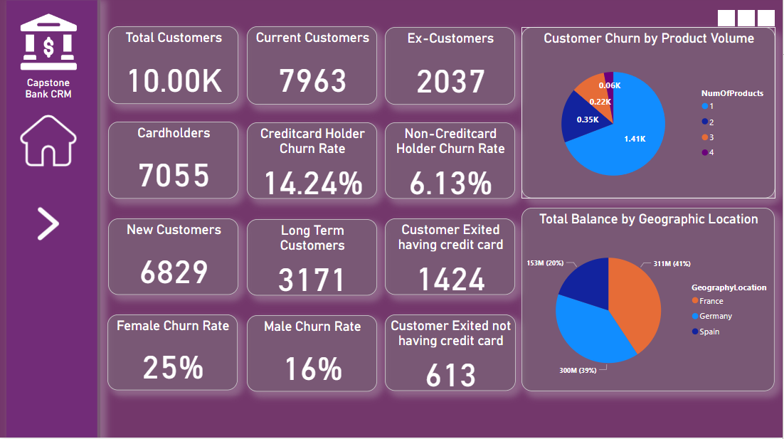

* 1. How would you approach this problem, if the objective and subjective questions weren't given?
* If the objective and subjective questions were not given, the approach to the problem would focus on understanding and analyzing the CRM bank dataset to derive insights and identify key factors influencing customer exits.
* Begin by exploring the dataset to understand its structure, variables, and relationships. Identify key variables such as customer demographics, account details,
* Conduct descriptive analysis to summarize the dataset and identify key trends, patterns, and distributions the dataset based on various factors such as demographics, product usage, and interaction history to identify groups of customers with similar characteristics.
* Analyze the churn rate (percentage of customers who exited) over time and identify any trends or seasonality in customer exits.
* Use visualizations such as bar charts, line charts, pie charts, and heatmaps to present your findings and insights in a clear and concise manner

approach would be to thoroughly analyze the dataset to understand customer behavior and identify actionable insights that can help reduce customer churn and improve customer satisfaction.

* 1. In the “Bank_Churn” table how can you modify the name of the “HasCrCard” column to “Has_creditcard”?

